Vocational Major Numeracy
VCE Vocational Major Numeracy focuses on enabling students to develop and enhance their numeracy skills to make sense of their personal, public and vocational lives. Students develop mathematical skills with consideration of their local, national and global environments and contexts, and an awareness and use of appropriate technologies.
This study allows students to explore the underpinning mathematical knowledge of number and quantity, measurement, shape, dimensions and directions, data and chance, the understanding and use of systems and processes, and mathematical relationships and thinking. This mathematical knowledge is then applied to tasks which are part of the students’ daily routines and practices, but also extends to applications outside the immediate personal environment, such as the workplace and community.
Units 1 & 2

Outcome 1. VCE Vocational Major Numeracy covers eight Areas of Study across Units 1 and 2
- Area of Study 1: Number
- Area of Study 2: Shape
- Area of Study 3: Quantity and measures
- Area of Study 4: Relationships
- Area of Study 5: Dimension and direction
- Area of Study 6: Data
- Area of Study 7: Uncertainty
- Area of Study 8: Systematics

These Areas of Study are framed around working mathematically across six different numeracy contexts:
  - Personal numeracy
  - Civic numeracy
  - Financial numeracy
  - Health numeracy
  - Vocational numeracy
  - Recreational numeracy.
Outcome 2. elaborates and describes a four-stage problem-solving cycle that underpins the capabilities required to solve a mathematical problem embedded in the real world.
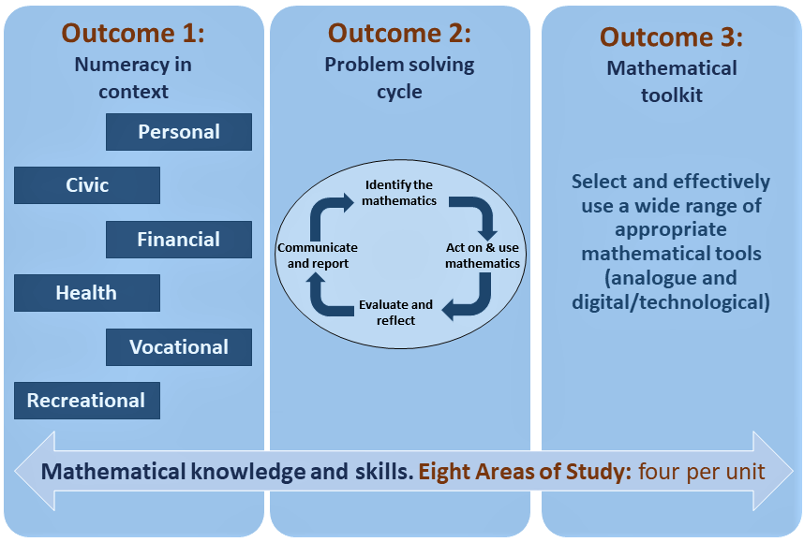
Outcome 3 requires students to develop and use a technical mathematical toolkit as they undertake their numeracy activities and tasks. Students should be able to confidently use multiple mathematical tools, both analogue and digital/technological.

