Year 9 (2024) into Year 10 (2025)

Subject Selections
Name: ____________________
Connect Group: _______

Contents

Important Dates 4
Activity 4
Year 10 at Oberon 4
Things to Consider 4
Accelerating a VCE Subject 5
VCE Subject for Acceleration 5
VCE Subject Information 5
Subject Options Year 10 – 2024 6
Compulsory Subjects 6
English 6
Mathematics 7
Optional Subjects 7
Languages 7
Elective Subjects 7
English Elective 7
Health and Physical Education 8
Humanities 8
Science 9
Technology 9
Arts 10
Subject Selection Examples 11
VCE Acceleration, Science Focus 11
Arts Focus, no VCE subject 12
PE/Health Focus, no VCE subject 12
Subject Selection Trial Form 13
Early Entry to VCE Form 14

Important Dates
Activity | Date | Time
Student Subject Expo | Wednesday 17th July | Periods 3/4
Parent Information Session | Thursday 18th July | 5.00pm – 7.00pm: Curriculum Leaders available for subject discussions.  6:00pm: Parent Presentation
Subject Selection Practice | Friday 26th July | Connect
Subject Selection Open | Tuesday 2nd August | 9.00am
Subject Selection Close | Tuesday 6th August | 3.30pm

Year 10 at Oberon
In year 10 students complete 12 units of study across the year. Each unit runs for one semester.
Students must complete:
- 2 Units of English
- 2 Units of Maths
The other 8 units are made up from the following curriculum areas:
- Arts
- Humanities
- Health & PE
- Languages
- Science
- Technology
- English (added elective)
You must complete at least one unit from each curriculum area. A maximum of three units can be chosen from any one curriculum area.
Students also have an opportunity to complete a year 11 subject during year 10.

Things to Consider
When deciding what subjects to select for year 10, take time to think about the following:
- What subjects do I enjoy?
- What subjects am I good at?
- What are your interests and passions? i.e. sport, outdoors, science
- Do I know anyone working in a job that seems appealing?
- What subjects do I need for further study? (pre-requisites)

Accelerating a VCE Subject
In order to complete a year 11 subject in year 10, you need to speak with your current subject teacher. For example, if you wish to do year 11 history, speak with your current humanities teacher. Your teacher will need to agree with your selection and sign the “Acceleration for VCE Subject – Year 10 2025” form – you will find this on the last page of this booklet. This form will also need to be signed by your parent or guardian.

VCE Subjects for Acceleration
Not all VCE subjects are available for early entry. Each curriculum area chooses subjects in which they believe students can achieve success. The following subjects are available for early entry in 2024:
Arts | Technology | Health/PE | Humanities | Science | Maths
Visual Art  Visual Communication Design  Music  Drama | Food Studies  Systems Engineering | Health and Human Development  Outdoor and Environmental Education  Physical Education | Geography  Business Management  Legal Studies  History  Accounting | Environmental Science  Psychology  Biology (additional consultation required) | General Maths

VCE Subject Information
More information about the different VCE subjects can be found at Victorian Curriculum and Assessment Authority website as well as on the Early Entry to VCE application sheet. There will be an opportunity to speak with each of the different subject teachers as part of the Parent Information Night on July 19th.

Subject Options Year 10 – 2024
Each curriculum area has a range of different subjects that you can choose from to complete in year 10. Each curriculum area’s subject offerings are listed below. More details about each of the subjects can be found on the next few pages.
English | Standard English  Extension English | Maths | General Maths  Extension Maths  Pre-Methods | Languages | German  Indonesian
Humanities | Legal Studies  Business Management  History | Health and Physical Education | Outdoor Education  Sports Performance  Fitness  Health | Technology | Wood  Food  Fibre  Digital Systems
Science | Alpha  Beta  Gamma | Art | Visual Art  Music  Drama  Visual Communication Design | English | Literature

Compulsory Subjects
Students must choose one subject for each curriculum area.

English
Standard English | Extension English
In Year 10 Standard English, students produce persuasive and expressive responses that explore the theme of ‘Hope’. Students read, discuss and analyse popular and contemporary texts. In addition, students are expected to use essay writing skills to explore and analyse a text. They use a variety of multimodal texts to support individual oral presentations and draw on a range of strategies to enhance a presentation. Additionally, students study the issue of 'Sustainability' and analyse how language is used to persuade in both written and audio visual texts. | In Year 10 Extension English, students produce persuasive and expressive responses that explore the theme of ‘Hope’. Students analyse classical imaginative texts that explore personal, social, cultural and political issues of significance to their own lives. In addition, students are expected to write: personal reflections and text responses; extended narratives that experiment with structure and style; and arguments that explore a complex issue and justify a viewpoint. They draw on a range of strategies to explore ideas through discussions and oral presentations. Additionally, students study the issue of 'Sustainability' and analyse how language is used to persuade in both written and audio visual texts.
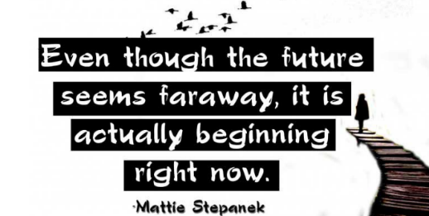

Mathematics
Core Maths | General Maths
In Core Maths students are learning a range of new concepts throughout the 3 main strands of mathematics, Number and Algebra, Measurement and Geometry as well as Statistics and Probability. They are given the opportunity to consolidate skills previously studied whilst doing so. A large focus is on real life skills including financial maths, measurement and project-based skills, geometry skills and data interpretation. | In General Maths students are learning a range of new concepts throughout the 3 main strands of mathematics, Number and Algebra, Measurement and Geometry as well as Statistics and Probability. They are given the opportunity to not only consolidate skills previously studied, but also to be better prepared for General Maths in VCE. This includes being extended in a range of different topic areas.
Math Methods
In Methods, students are learning a range of new concepts throughout the 3 main strands of mathematics; Number and Algebra, Measurement and Geometry as well as Statistics and Probability. They are being prepared for studying the subjects of Maths Methods and Specialist Maths in VCE, which includes a strong focus on algebra and graphs. Students who are motivated and enjoy math are encouraged to pursue this path.

Optional Subjects

Languages
Languages are optional at Year 10. If you do decide to choose a language you must pick it in both semesters.
German | Indonesian
German in Year 10 – topics include holiday activities, exchange trips, music, shopping, Berlin and the Goethe Institute’s Enterprise German project – working with an Australian German-speaking company such as the “Hofbräuhaus”, “Haribo”, “BMW” to develop a new product or business idea. Schools from around Australia take part and a group from Oberon placed second in 2023. | Indonesian in Year 10 – Students take a trip through Indonesia, exploring major cities like Denpasar and Yogyakarta. They focus on practical skills such as navigating through the airport and ordering at restaurants. There is also a focus on folklore as students perform their own traditional stories.

Elective Subjects
Students must choose one subject from each curriculum area.

English Elective
Literature
If you have a passion for creative writing and reading, then Literature could be for you! In Year 10 Literature, students study poetry and creative writing across a range of different genres. Literature students discuss and analyse ‘The Great Gatsby’ and reflect upon the creative processes used by writers to develop their work. Year 10 Literature opens a pathway into VCE Literature and complements the study of VCE English.

Health and Physical Education
Outdoor Education | Sports Performance
This subject would suit students with the desire to try a range of outdoor pursuits. Students will be given the opportunity to participate in a variety of outdoor experiences including rock climbing, surfing, and sea kayaking. There is an environmental focus in this unit where students will investigate the different types of outdoor environments as well as sustainability and managing risks in the outdoors. This unit provides a great introduction to some of the concepts studied in VCE Outdoor and Environmental Studies. | In Year 10 Sports Performance students attend 3 practical sessions and 2 theory sessions each week. Students continue to explore the body systems with a focus on the musculoskeletal system including injury management and performance enhancing drugs. The students will evaluate a range of psychological strategies used to enhance performance. Students will investigate skill acquisition and coaching concepts and apply them to a variety of sports. This subject is a great introduction to VCE Physical Education.
Health | Fitness
Year 10 Health provides students with the opportunity to develop their knowledge and understanding of health and wellbeing. Students will explore a variety of topics including the dimensions of health, nutrition, Australia’s health status, system, health resources and key factors of influence. This subject is a great introduction to VCE Health and Human Development. | In Year 10 Fitness students attend 3 practical sessions and 2 theory sessions each week. In practical classes students will complete a variety of training sessions both in and out of school. The theoretical concepts of this subject provide students with the opportunity to further explore the body systems with a focus on the cardiovascular & respiratory systems. Students will collect and analyse class data before exploring types of training, training methods and training principles. This subject is a great introduction to VCE Physical Education.

Humanities
Business Management | Coastal Geography
In Business Management students will gain an insight into the world of small business as well as develop skills in business management and accounting. They will deepen their understanding of the challenges facing small businesses in changing environments and the relationships between the various stakeholders. | In Coastal Geography, students will develop their ability to understand and work with both the human and natural environments. They will improve their skills in mapping, grid referencing, sketching, online information sources, and fieldwork. They will also investigate the management of coastal environments and climate change.
History | Legal Studies
In History students will learn about key historical figures, the context in which they lived, and their impact on the course of world history. Evaluate a range of information to develop your own conclusions on individuals and historical events. ​ | In Legal Studies, students will investigate Australian citizens’ legal rights and responsibilities, our system of criminal and civil law, and resolution of disputes. They will look at the Constitution, Levels of Government, and how laws are made and altered to deal with the changes in our society.

Science
Science Alpha | Science Beta
Students learnt about the composition and structure of DNA, genes and chromosomes and how cells pass these on during growth and to future generations. They investigated how inheritance and differences in gene expression cause change over time in species characteristics. Students were introduced to the periodic table of elements, chemical language and formula. They compared the structures of atoms and ions and reactivity of elements. Students observed chemical reactions that produced electricity and the basic construction of a battery, contrasting with electricity production by magnetic induction. They investigated electric circuits and motors. | Students described the structure and function of plant cells and systems. They investigated the photosynthesis reaction that occurs in leaves, transpiration of water and dissected the reproductive parts of different flowers. They investigated biological chemical reactions and molecular structure involved in photosynthesis, respiration, and foods. They also looked at non-food polymers including plastics. Students investigated the physics of motion, including the analysis of position, velocity and acceleration. Newton's laws were applied to theoretical and real life situations including car collisions and car safety devices.
Science Gamma
Students investigated the structure and function of the brain and nervous system. They learnt how animals respond to stimuli using both nervous and hormonal pathways Students studied the properties and uses of metals and how these are extracted from the minerals of the Earth. They studied nuclear fusion in stars, the composition of the universe. They investigated the forces and energy required for space flight and compared their rockets built from a template design.

Technology
Wood | Food
Year 10 Wood Design Technology prepares students for VCE Product Design. It runs for one semester, developing skills in designing, investigating, producing, and evaluating timber projects, whilst practising safe work procedures. Students working in this unit will learn Computer Aided Design (CAD) programs and have access to a range of equipment, for learning specialised skills in these areas. | Food Technology focuses on food safety, food packaging and labelling, food science, Australian Guide to Healthy Eating and links to breakfast, lunch, dinner and dessert. Students investigate how to prepare a variety of foods throughout the semester, addressing appropriate nutritional requirements and presentation techniques. The technology-based process of investigation, design, producing and evaluating is applied throughout the subject, particularly when completing design tasks.
Fibre | Digital Systems
Technology Design Fibre focuses on delivering skills in designing and investigating, producing, analysing and evaluating of a variety of clothing and fibre manufacture. The students have an opportunity to investigate and apply more complex skills and techniques to produce individual products, whilst practising safe work procedures.  Throughout the semester students will have the opportunity to make three projects using a range of skill from Upcycling to garment construction using a commercial pattern. | Digital Systems at Year 10 provides students with an opportunity to develop understanding of fundamental electrical and mechanical systems, and then secure this understanding via practical application in individual and group projects. Throughout this unit students will engage in short term and long-term practical projects which will also help them to develop key collaboration and project management skills and build critical industry specific skills such as computer programming and 'Computer Aided Design'.

Arts
Visual Design - Art | Drama
Visual Arts at Year 10 is designed to allow students to learn and appreciate major historical art movements via engagement in practical projects. Projects start inspired by the art of ancient cultures, then progress through time exploring and responding to historical and contemporary art movements. Students are encouraged to explore a wide range of art materials and techniques and are provided options to help them express their individual story and style through their individual creative practice. Art theory is balanced with practical projects, with a focus on reading visual language and interpretation through written analysis. | Year 10 Drama further builds the student’s knowledge of expressive and performance skills. Students work collaboratively to write and produce a radio play for presentation to an audience. Students study the origins of Australian drama and explore Australian playwrights, working in small groups to bring scripts to life. Students may also write their own solo or group performance based on the themes explored in this unit.
Music | Visual Communication Design
Music at Year 10 focuses on the development of performance skills. Students present a program of prepared solo and group works. Students research a variety of factors that can impact performances and devise strategies to address these factors. They also explore current trends in the music industry and the topic of copyright. Music theory is studied, including the development of aural skills and the ability to recognise and notate intervals, rhythms, chords, and scales. Students negotiate a project topic that can encompass a range of options including artist and/or instrument research, creative music tasks, exploring music genres and song writing. | Visual Communication Design focusses on the communication of ideas and the presentation of information in 2D and 3D. Students will have the opportunity to refine freehand drawing skills, develop instrumental drawing skills and computer skills. They will exploring different rendering techniques and experiment with a range of manual and digital media through practical tasks. Students follow a design process to think creatively and to solve design problems. Topics are varied and represent the four fields of design: messages, objects, environments, and interactive experiences.

Subject Selection Examples
Below are three different examples of ways that you can choose subjects in year 10. There are endless different subject combinations which can be chosen. Use the examples below to get some ideas!

VCE Acceleration, Science Focus
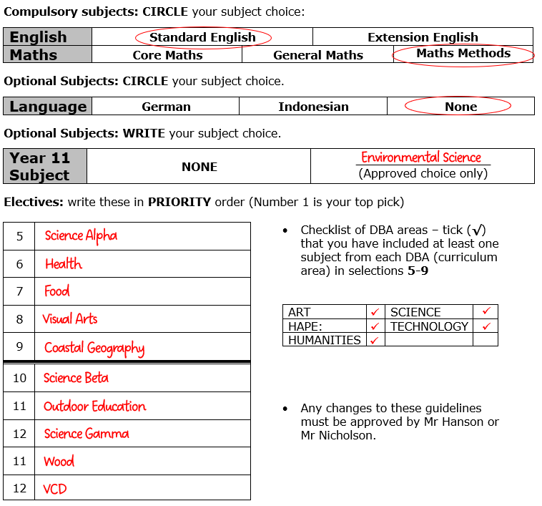
The student has decided to focus on sciences, choosing multiple subjects from this curriculum area. They have spoken to their current year 9 teacher and have permission to accelerate into Year 11 Environmental Science.
The student has decided to not pursue their language into year 10 and has chosen their English and Maths subjects after consultation with their current teachers.
In their electives, the student has ensured they have included one subject from each curriculum area in picks 5 through 9.

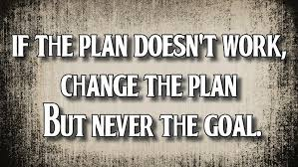

Arts Focus, no VCE subject

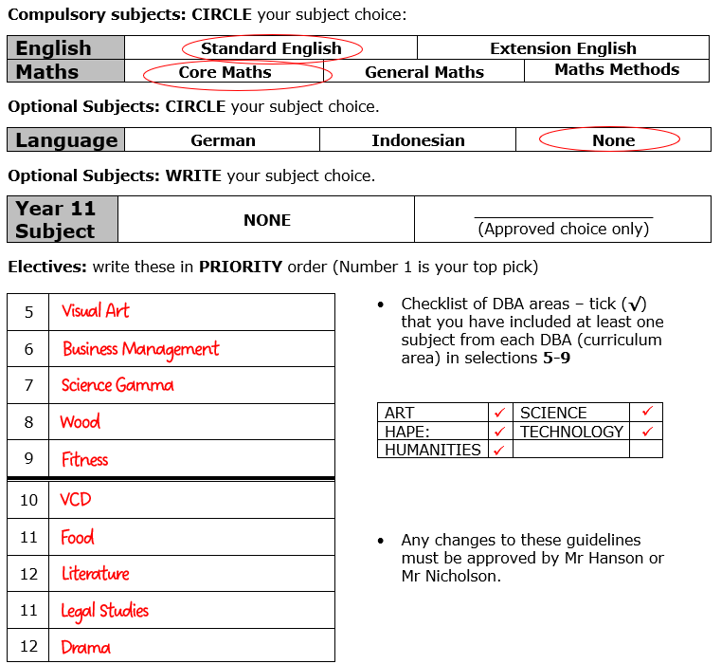
The student has decided to focus on Arts, choosing multiple subjects from this curriculum area. They also like the idea of maybe one day running their own business, so they have chosen Business Management and Legal Studies.
The student has decided to continue with Indonesian in year 10 and has chosen their English and Maths subjects after consultation with their current teachers.
In their electives, the student has ensured they have included one subject from each curriculum area in picks 5 through 9.

PE/Health Focus, no VCE subject
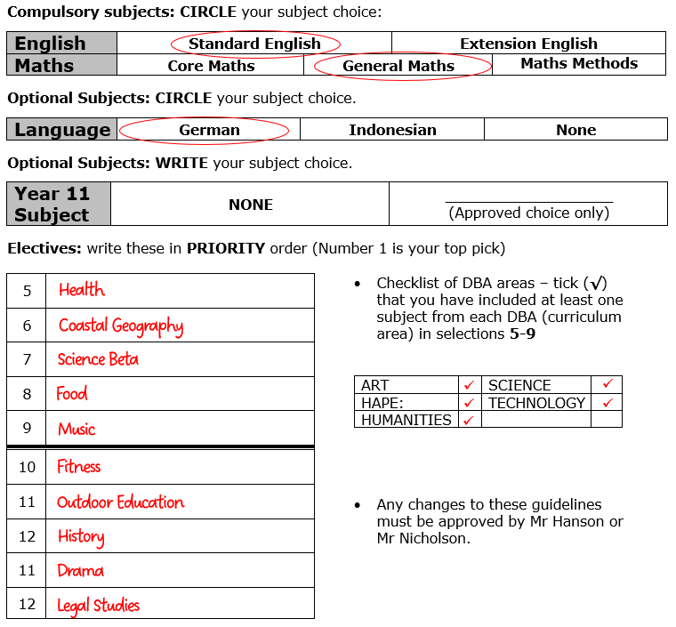
The student has decided to focus on Physical Education and Health, choosing multiple subjects from this curriculum area. They also enjoy humanities, so have chosen some subjects from this area.
Wanting to keep their options, the students has chosen a science that allows them options in VCE. They have decided to continue with German in year 10.
In their electives, the student has ensured they have included one subject from each curriculum area in picks 5 through 9.

Subject Selection Trial Form
Use this page to have a go at choosing your subjects for next year. You will receive your final form in Connect on Friday July 31st.
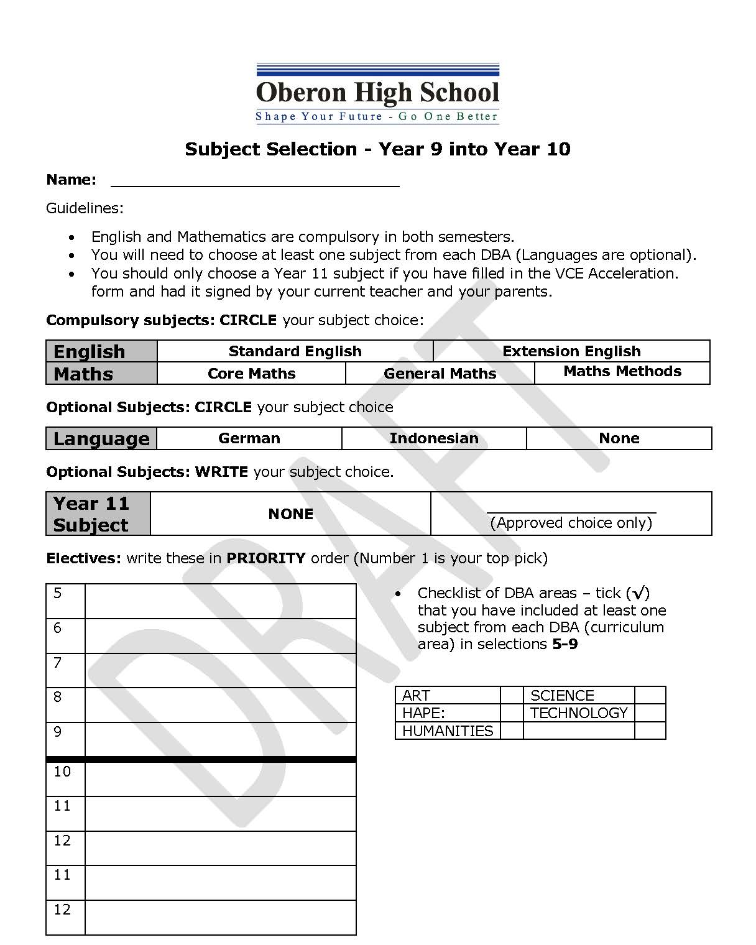

Early Entry to VCE Form
If you wish to undertake a year 11 subject in year 10, 2025, this form needs to be completed and returned with your subject selection form to Mr Hanson or Mr Nicholson. More information about each of the subjects on offer can be found on the next few pages.

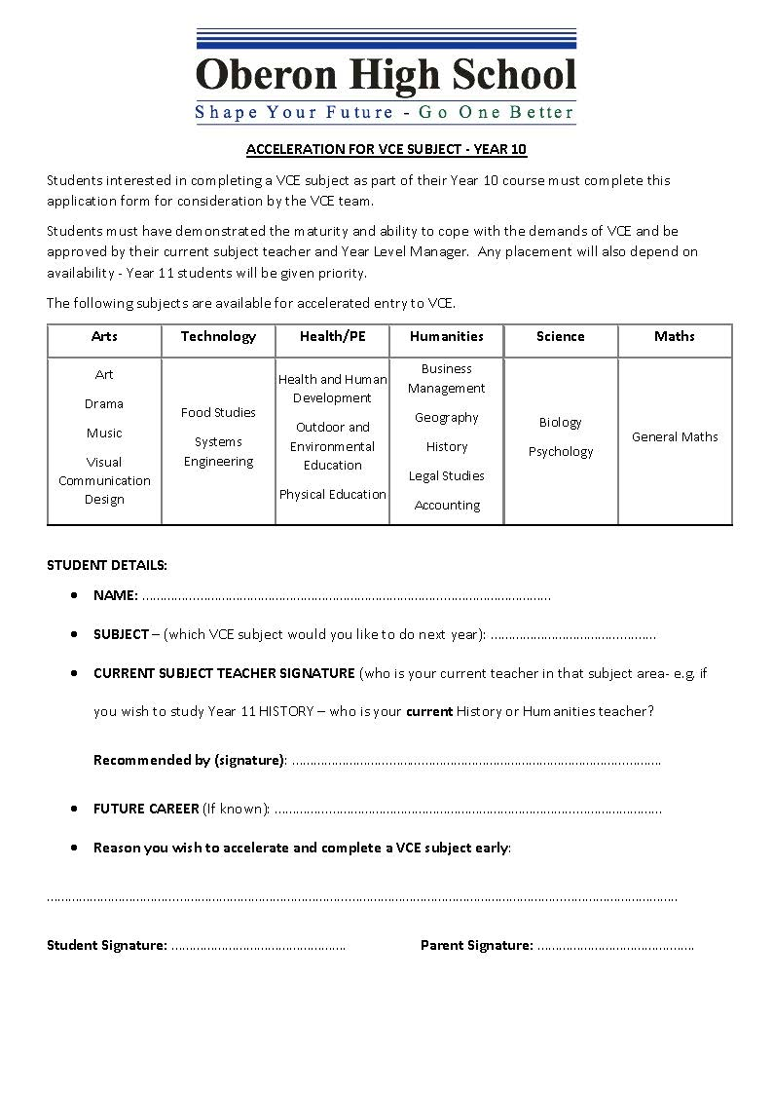

Subject Options VCE Early Entry

Arts
Music | Drama
Unit 1: Creating  Students learn how music is organized by performing, creating, and analysing different types of music. They perform solo and group pieces to improve skills and expression, focusing on at least two pieces with different organizational approaches. They write, arrange, or improvise short pieces to demonstrate their understanding of music organization and study various pieces to see how composers use different elements and techniques.  Unit 2: Effect in Music  Students explore how music creates different effects by performing, analysing, and responding to various pieces. They improve their skills and expression through independent and group performances, focusing on at least one piece that creates a specific effect. They write, arrange, or improvise short pieces to demonstrate their understanding of music organization and study how musicians use elements and techniques to express ideas. They learn to identify, recreate, and notate these musical ideas. | Unit 1: Introducing Performance Styles  Students explore multiple performance styles from diverse social, historical, and cultural contexts, studying drama traditions like rituals and storytelling to create original performances. They focus on creating, presenting, and analysing solo and ensemble performances with real or imagined characters, based on various experiences. Using play-making techniques, expressive skills, and different styles, students document their creative process and experiment with production areas, dramatic elements, conventions, and styles.  Unit 2: Australian Identity  Students explore Australian identity through contemporary drama, studying the work of Australian drama practitioners and performance styles. They create, present, and analyse performances based on Australian themes, using materials to explore identity and examining various performance styles and conventions. They analyse their own and professional Australian performances, reflecting Indigenous voices, migrant experiences, or urban and rural perspectives. The unit covers multiple performance styles and contexts.
Visual Arts | Visual Communication Design
Unit 1: Interpreting Artworks and Creative Practice  In Unit 1, students engage in experiential learning by creating and analysing artworks within the Creative Practice. They explore how artists communicate ideas and meanings, studying diverse artists across societies, cultures, and history to form their interpretations. Through experimentation with various materials and techniques, students cultivate technical skills and creativity in both traditional and contemporary art practices.  Unit 2: Interpreting Artworks and Developing Creative Practice  Unit 2 emphasizes inquiry into artistic and collaborative practices using the Cultural Lens and other interpretive methods. Students investigate how artists interpret social and personal ideas through artworks across different historical and cultural contexts. They create visual responses informed by their research, exploring how cultural influences shape artistic practices from past to present. Students explore the societal functions of art, examining its role in expressing and challenging social norms. | Unit 1: Finding, reframing and resolving design problems  Students learn practices and processes to identify, reframe, and resolve human-centered design problems, exploring how design improves life and how concepts of good design have evolved. They use human-centered research methods and collaborative work to discover design problems, understand stakeholder perspectives, and create design briefs. The unit introduces the VCD design process, integrating divergent and convergent thinking for future projects.  Unit 2: Design contexts and connections  Building on Unit 1, students apply the full VCD design process, focusing on designing environments and interactive experiences. They adopt practices from architecture, landscape architecture, interior design, and UX design, exploring methods, media, and materials. The unit emphasizes the connections between design and its context, the emotional impact of interactive design, and the influence of historical and cultural design traditions. Students refine their design decision-making and critique skills.

Humanities
Business Management | History
Unit 1: Planning a Business  Students explore the factors affecting business ideas and the internal and external environments in which businesses operate. They study the impact of these factors on business planning and consider the importance of the business sector to the national economy and social wellbeing.  Unit 2: Establishing a Business  Students focus on the establishment phase of a business, examining legal requirements, financial record-keeping, staffing, and building a customer base. They investigate effective marketing strategies and analyse contemporary business case studies to understand management practices. | Unit 1: Change and Conflict  In this unit students investigate the nature of social, political, economic and cultural change in the later part of the 19th century and the first half of the 20th century. Modern History provides students with an opportunity to explore the significant events, ideas, individuals and movements that shaped the social, political, economic and technological conditions and developments that have defined the modern world.  Unit 2: Social and cultural change  In this area of study students focus on the social life and cultural expression in the late nineteenth century and the first half of the twentieth century, and their relation to the technological, political and economic changes of the period. Students explore particular forms of cultural expression from the period.
Legal Studies | Accounting
Unit 1: The Presumption of Innocence  Students learn about legal foundations, types and sources of law, and the characteristics of effective laws. They explore principles of justice and key concepts of criminal law, applying these to real or hypothetical scenarios to determine culpability. Students gain insight into how criminal cases are resolved and the purposes of sanctions by examining recent cases.  Unit 2: Wrongs and Rights  Students study civil law concepts and apply them to scenarios to determine liability. They explore various civil law areas, resolution methods, and institutions, investigating recent civil cases. Additionally, students learn about human rights protection in Australia, potential reforms, and analyse a contemporary human rights issue through a specific case study. | Unit 1: The Business Idea  Students explore entrepreneurship, how business ideas are created, and the conditions fostering new ideas. Sources include market gaps, technological advances, and changing customer needs. The unit also examines considerations before establishing a business and its importance to the economy and social wellbeing.  Unit 2: Establishing a Business  This unit covers the role of accounting in business success or failure and its importance to stakeholders. Students analyse and evaluate business performance using financial and non-financial information to make investment recommendations. They record financial data and prepare reports for sole proprietorships, incorporating the Conceptual Framework, financial indicators, and ethical considerations in decision-making.
Geography
Unit 1: Hazards and Disasters
This unit explores how people respond to hazards and disasters. Hazards have the potential to cause harm, while disasters are severe disruptions impacting communities. Hazards range from local issues like traffic and coastal erosion to global threats like drought and infectious diseases.
Unit 2: Tourism: Issues and Challenges
Students examine tourism's development, forms, changes, and impacts on people, places, and environments. They investigate ethical tourism, using examples from Australia and worldwide. Tourism involves travel away from home for over 24 hours but less than a year. The industry significantly affects environments, economies, and cultures, providing many jobs and contributing to global GDP.

Science
Psychology | Environmental Science
Unit 1: How are behaviour and mental processes shaped?  Students explore the complexities of psychological development, including atypical cases, and consider insights from both Western and non-Western societies, including Aboriginal and Torres Strait Islander peoples. They study the human brain's structure, function, brain plasticity, and the impact of brain damage on psychological functioning.  Unit 2: How do internal and external factors influence behaviour and mental processes?  Students assess the impact of social cognition on attitudes, self-perception, and relationships, considering cultural differences and the experiences of Aboriginal and Torres Strait Islander peoples in Australia. They investigate how various factors influence individual and group behaviour, study human perception, and examine how distorted perceptions can affect interactions with the world. | Unit 1: How are Earth’s dynamic systems interconnect to support life  Students study the interactions within Earth's four systems: atmosphere, biosphere, hydrosphere, and lithosphere. They focus on ecosystem functions affecting environmental conditions like plant productivity, soil fertility, and water and air quality. They explore historical changes to predict future impacts and consider factors for responsible environmental management.  Unit 2: What affects Earth’s capacity to sustain life?  Students explore pollution and food and water security as complex environmental challenges. They examine pollutants' characteristics, impacts, and management, and factors influencing the sustainable supply of food and water.

Technology
Food Studies | Systems Engineering
Unit 1: Food Origins  Students explore the historical and cultural aspects of food, tracing its sourcing from hunting and gathering to farming, urban living, and global trade. They study a specific food-producing region's history and practices, then focus on Australia's Indigenous food traditions and their evolution post-European settlement. The unit also examines the impact of immigration, industry, new technologies, and globalization on Australian cuisine. Practical activities are included to apply and share learning.  Unit 2: Food Makers  Students investigate contemporary food systems in Australia, focusing on commercial food production's economic contribution and quality standards. They compare commercial production with home and small-scale production, learning the benefits and challenges of home food preparation. Students create food products, adapt recipes, and explore small food business potential. Practical activities enhance cooking skills and emphasize effective food provision and preparation in daily life. | Unit 1: Systems Engineering - Mechanical Systems  Students learn about mechanical systems like gears, levers, pulleys, and hydraulics. They complete a mechanical/electrical project of their choice, such as robots, flying wings, or vending machines. Assessment includes class tests, an end-of-unit exam, and a folio with a work journal and practical work.  Unit 2: Systems Engineering - Electrotechnology Systems  Students study electrical systems, including circuits, electrical components, and programmed hardware. They complete a mechanical/electrical project similar to those in Unit 1.  Practical vs. Theory Work  Systems Engineering focuses on hands-on practical work, with most class time dedicated to projects. Students can work alone or with a partner. The practical component constitutes 50% of the assessment, with the work journal, tests, and exams making up the other 50%.

Health and PE
Health and Human Development | Outdoor and Environmental Education
Unit 1: Understanding Health and Wellbeing  Students explore health and wellbeing as varied and evolving concepts with different interpretations. They study the World Health Organization’s (WHO) definition and conditions for health, examining health inequities through a social justice lens. The unit covers multiple dimensions of health, influences on health outcomes, and measurement indicators. Focusing on youth, students enhance health literacy by researching a youth health area and investigating the role of food.  Unit 2: Managing Health and Development  Students examine health and wellbeing transitions from youth to adulthood, considering changes, expectations, and increasing responsibilities. They apply health literacy skills, exploring adulthood's milestones, relationships, and health management. The unit includes investigating the Australian healthcare system, challenges and opportunities of digital media, and issues related to health data and access to quality care. | Unit 1: Connections with Outdoor Environments  Students explore how Indigenous and non-Indigenous peoples understand and relate to nature through outdoor experiences, focusing on personal responses and motivations. They study factors affecting access to outdoor environments and develop practical skills for sustainable interaction with nature. The unit links practical experiences with theoretical insights into various perspectives on nature.  Unit 2: Discovering Outdoor Environments  Students examine human impacts and natural changes in outdoor environments through case studies. They learn practical skills to minimize human impact and explore vocational perspectives on using outdoor environments. The unit involves reflecting on experiences and developing theoretical knowledge about natural environments.
Physical Education
Unit 1: The Human Body in Motion
Students explore how the musculoskeletal and cardiorespiratory systems work together to produce movement, examining main structures and their responses. Through practical activities, they analyse the interaction between body systems at various intensities. Students investigate conditions and injuries related to the musculoskeletal system, recommending strategies for prevention and management. They also evaluate the ethical implications of enhancing body system performance with permitted and prohibited practices.
Unit 2: Physical Activity, Sport, Exercise, and Society
Students understand physical activity, sport, and exercise from a participant's perspective, learning about different types of physical activity and their impact on health and wellbeing. They explore various activities, assess barriers and enablers to participation, and apply the social-ecological model to promote regular physical activity. Students create personal movement plans and investigate contemporary issues affecting access, inclusion, participation, and performance in physical activity. They analyse one local, national, or global issue in depth, considering its historical, current, and future implications.

Maths
General Maths
Unit 1: General Mathematics
Unit 1 of General Mathematics covers ‘Data analysis, probability and statistics’, ‘Algebra, number and structure’, ‘Functions, relations and graphs’, and ‘Discrete mathematics’. Students will apply techniques involving arithmetic, algebraic manipulation, equations, graphs, and geometric constructions, both manually and with technology. They should be proficient in estimation and computation using mental and manual methods, and utilize technological tools for numerical, graphical, symbolic, financial, and statistical purposes as appropriate.
Unit 2: General Mathematics
Unit 2 of General Mathematics includes ‘Data analysis, probability and statistics’, ‘Discrete mathematics’, ‘Functions, relations and graphs’, and ‘Space and measurement’. Students will apply techniques involving arithmetic, algebraic manipulation, equations, graphs, and geometric constructions, both manually and with technology. They should be proficient in estimation and computation using mental and manual methods, and utilize technological tools for numerical, graphical, symbolic, financial, and statistical purposes as appropriate.

